TC-REF-010
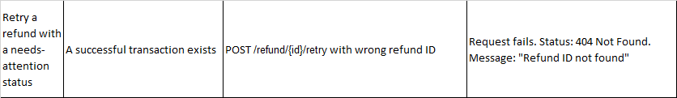
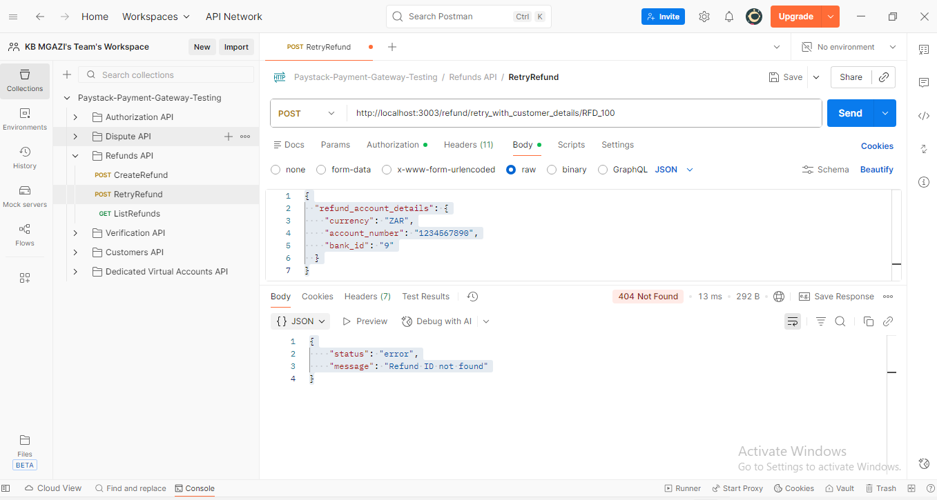
Request:
{
"refund_account_details": {
"currency": "ZAR",
"account_number": "1234567890",
"bank_id": "9"
}
}

Response:
{
"status": "error",
"message": "Refund ID not found"
}

